PBI ASSIGNMENT-5

1. Explain DAX.

* DAX is a collection of functions ,operators and constants that can used in a formula, expression, to calculate & return one or more values.
* By using DAX, we can create smarter calculated columns & measures by which we can limit the data, the dashboard has to fetch and visualize.
* Also called a formula expression language or function language & can be used in different BI and visualization tools where full code is kept inside a function.
* DAX programming formula contains two data types, Numeric and Other.
  + - * Numeric – Integers, Currency & Decimals
      * Other – Strings & Binary objects
* DAX function can also include other functions, conditional statements & value references. Such as,
  + - * Aggregate – min(), max(), sum(), avg(), sumx()
      * Text – replace(), search(), upper(), fixed(), concatenate()
      * Date – date(), hour(), weekday(), now(), eomonth()
      * Logical – AND, OR, NOT, IF, IFERROR
      * Counting – distinct count(), count(), countA(), countrows(), countblank()
      * Information – isblank(), isnumber(), istext(), isnontext(), iserror()

1. Explain datasets, reports, and dashboards and how they relate to each other?

* DATASETS – Dataset includes the data, tables, relationship, and calculations. Here are some components that are part of the dataset.
  + - * The connection to the data source, tables and their data.
      * Calculated columns, tables, measures and hierarchies.
      * Formatting and setting of the fields (visibility, formatting, display folders, sort by column, data category).
* REPORTS – A Power-BI report is a multi-perspective view into a dataset, with visuals that represent different findings and insights from dataset. A report can have a single visual or pages of full of visuals.
* DASHBOARD – Dashboard is a visual display of all of our data. While it can be used in all kinds of different ways, its primary intention is to provide into at-a-glance, such as KPIs. A dashboard usually sits on its own page and receives from a linked database.
* Dashboards are created from multiple datasets or reports. It always concentrate on building insights into the data by using graphs, attractive visuals, charts, other than reports looks to create summary pages.

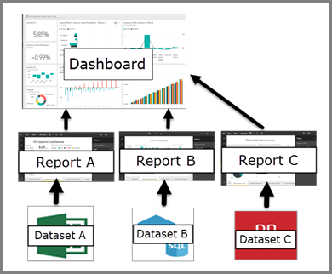

1. How reports can be created in power BI, explain two ways with Navigation of each.

* A Power-BI report is the ‘Power-BI way’ of showing findings and insights from a dataset.
* 1st WAY – Can create Power-BI report on Power-BI Desktop Tool.
* Install Power-BI Desktop for Power-BI report server.
* After download the installer, run the Power-BI Desktop setup-wizard.
* At the end of the installation, check starts Power-BI Desktop now.
* Select a data source. From the welcome screen-> select get data -> select data source -> import the data -> load the on Power-BI field.
* Design report. We can create visuals that illustrate our data.
* Save report to report server or can save on local computer.
* Publish to Power-BI report online in the Power-BI service.
* 2ND WAY – We can direct create Power-BI report on Power-BI Web Tool. Power-BI web tool enables us to directly import the data source onto Power-BI on the web and automatically generate the report.
  + - * Selecting our data source. Go to left navigation pane and click on the ‘create’ button. Only paste data directly or choose data from excel file.
      * Selecting the data types for attributes. Power-BI automatically detects the data types, but we have the option to manually set them using the data type button to the left of the column name.
      * Summarizing our data source using create flow. It enables us to create a new data set and automatically generates a summarized version of the data using create flow.
      * This helps us to transform raw data into valuable insights within a matter of clicks.
      * Editing fields using the summarize pane. Power-BI report design method, we can make reports as per our needs by editing them easily.

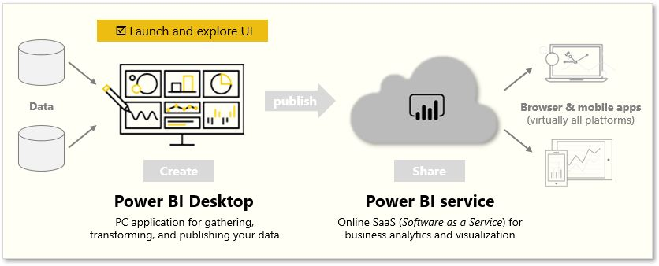

1. How to connect to data in Power BI? How to use the content pack to connect to Google Analytics? Mention the steps.

* To connect the data, from home ribbon select get data. The get data window appears. Then can choose from the many different data sources to which Power-BI Desktop can connect.
* Google Analytics is one of the most popular website performance tracking tools that companies use to measure progress toward online marketing goals. It enables digital marketing teams to gain insights into their audience’s navigation behavior and preferred ways of interacting with content.
* STEPS –
* In the service box, click get
* From the menu of online services, select Google Analytics and click connect.
* Enter the Google Analytics account, property, view that we want to connect. Then sign in with Google Analytics Credentials.
* To permit Power-BI to connect to Google Analytics, click Accept.
* When the import process completes, we will see a new dashboard to view our imported data.
* We can also import Google Analytics data directly into Power-BI Desktop.
* Get data -> dropdown menu, click more -> Google Analytics -> connect -> continue -> accept ->connect
* Now we can start creating our amazing dynamic reports.

1. How to import Local files in Power BI? Mention the Steps.

* We can connect to or import data and reports from various types of files like Microsoft Excel(.xlx or .xlsm), Power-BI Desktop(.pbix), Comma Separated Value(.csv) and many more.
* STEPS –
* Go to “Home” tab. There we choose “get data -> more” option.
* This will open the get data dialog. Click folders and then click connect. A new dialog box opens in which we have to provide the folder path that has our intended files.
* After selecting the file path, we click ok.
* We can see that the files are read successfully. Now we can choose to either combine or directly load the files or to combine and transform to go to the power query editor.

1. In Power BI visualization, what are Reading View and Editing View?

* Reading View is our way to explore and interact with reports created by colleagues. We can get most of things but not able to drag and drop.
* Even in reading view, the content is not static. We can dig in, looking for trends, insights & other business intelligence.
* Editing View is used by report designers, who create the reports and share them with us. We can delete and edit datasets.